**Home Work**

**Task 01:**

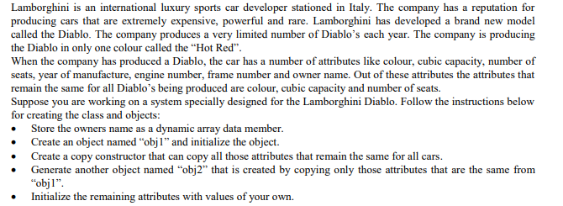

**Task 02:**

Your task is to create a class that contains an integer pointer data member. Create a single object named “one” in the



**END**